Intention & Surprise:
Printmaking with Akua Inks

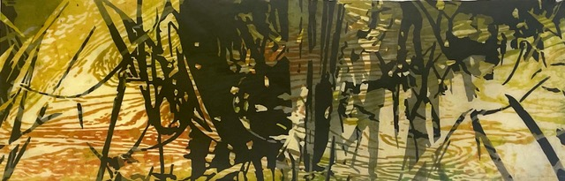  Against the Grain #28, Catherine Kernan | 4-day workshop  (two full & two ½ days)  with Catherine Kernan  June 1 – 4, 2023  Peconic Press  7134 Indian Neck Lane  Peconic, NY 11958
Modifying and controlling the viscosities of inks yields results that cannot
be achieved any other way. Understanding the interaction of inks is fundamental. Taking advantage of the ink interactions allows the development of multi-color prints from a single plate, and naturally leads to sequences of related images.

This four- day intensive workshop will introduce and deepen your understanding of how to mix, modify, and use Akua inks to their full potential for your work, while drawing inspiration from the surroundings.
Some experience is recommended; limit of 4 participants to allow for focused individual attention and use of large rollers.

Arrive 1:00 pm Thursday, June 1, welcome gathering end of day.
Friday & Saturday, in studio 9:30am – 4:30 pm; Sunday 9:30 - 1:00
Fixings for make-your-own lunch are provided Friday - Sunday
Discussion & critique at the end of the workday.

$650 workshop cost includes materials (except paper) and 3 lunches. 4 participants. Local restaurants abound for other dinners. Accommodations available at local B&Bs & Inns - see Wendy for details.

COVID protocol: double & boosted vaccinations and negative antigen home test required.
Contact Wendy and/or Catherine for details:
wendyprellwitz@gmail.com 617-448-3605
catherinekernan@comcast.net 617 909-7107
About Peconic Press  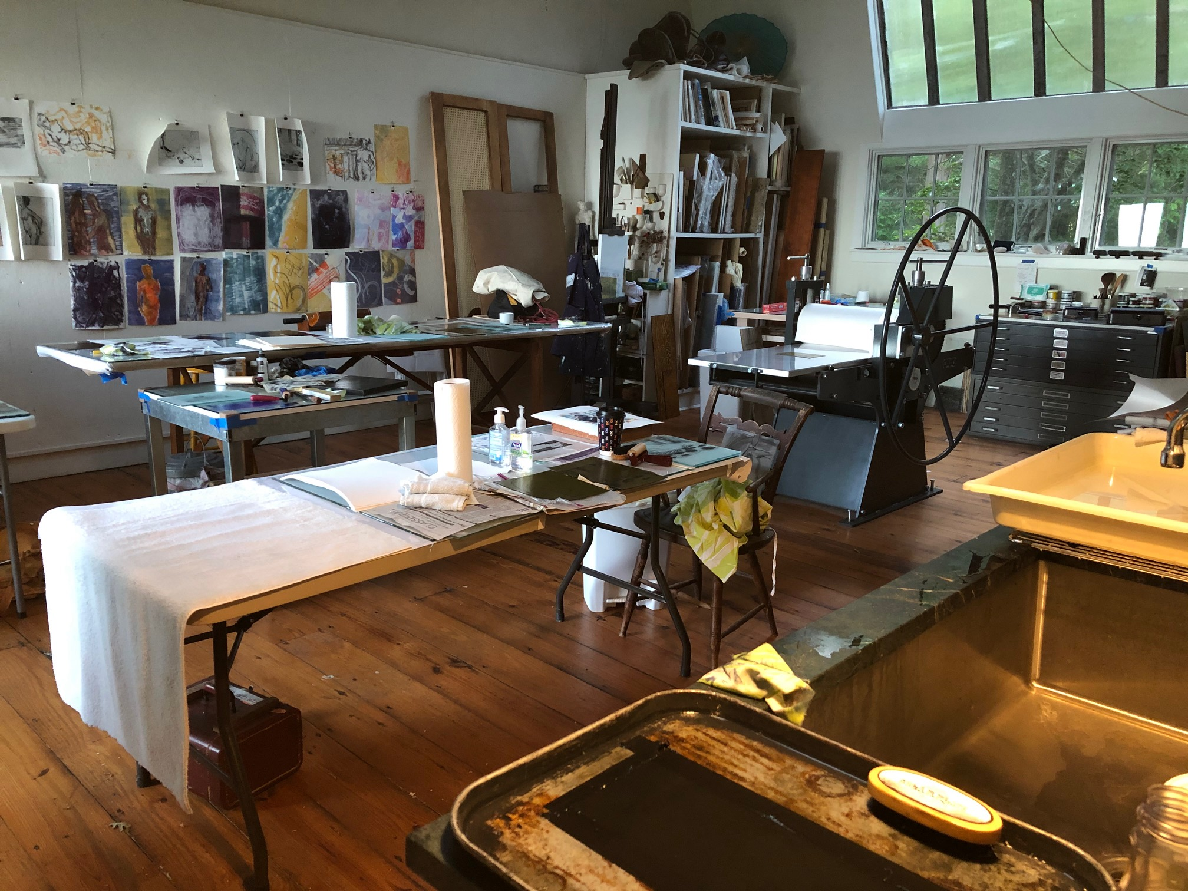  The workshop is located at artist Wendy Prellwitz’ studio on the North Fork of Long Island, in Peconic, NY. The studio and historic residence next door were once home to artists Edith & Henry Prellwitz, (Wendy’s great-grandparents) who were part of the Peconic Art Colony. Situated on a bluff above the beach, the house and double-studio overlook Peconic Bay. | 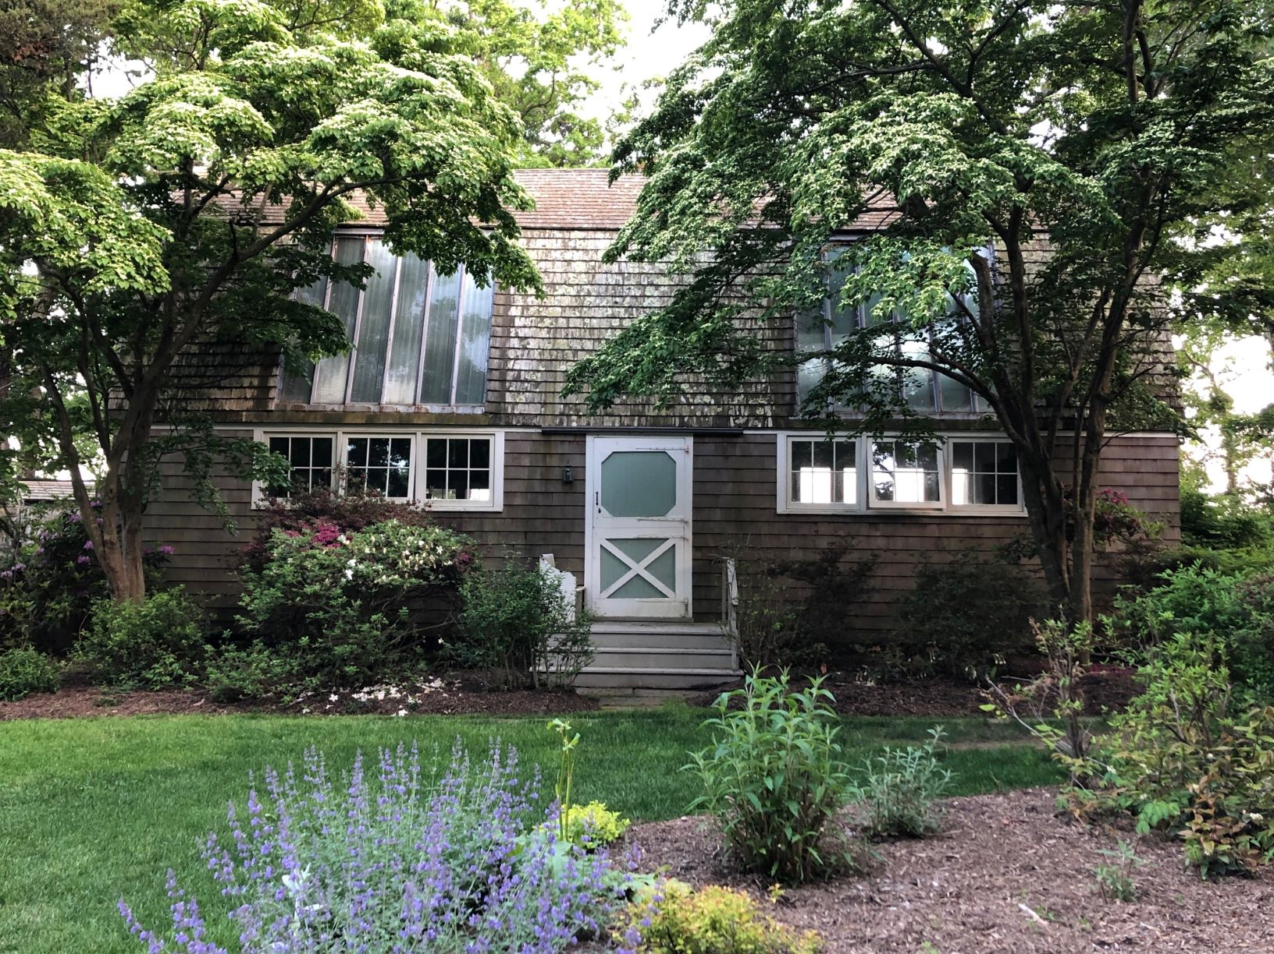  Studio & view of bay  